internship schedule leoni + manolie

w 1 (deepen understanding of topic)

mi 26.02 meeting rea, have topic so she can give feedback, ask on assignment dates

do 27.02 workshop day

which assignment when the company and its role

w2

mi 05.03 meeting rea

do 06.06 workshop value chain?

w3

mi 12.03

do 13.03 themenfindung lithium ionen, mapping, co working

wk 4

mi 19.03 meeting rea

do 20.03 brainstorm session

w5

mi 26.03 meeting rea

do 27.03

w6

mi 02.04 meeting rea

do 03.04

w7

mi 09.04 meeting rea

do 10.04

**Chris Website:**

<https://github.com/Value-Chain-Hackers/LiCycle-AI>

<https://viridis.info/l_en/>

**Our topic: Electro Waste& Recycling of Critical Raw Materials**

**Focusing on: Lithium-Ion Batteries- the electric storage system of the future**

Tech= Fast Pacesd Industry → Push for waste as “Trend” / Planned obsolescence

New technology = Innovation to tackle current Global issues, e.g. energy crisis → solar

→ Net Zero goal, Paris Agreement, new Regulations

underlying need/source for innovation = Critical Raw Material

* Germanium …
* Lithium …
* Cobalt….

Simultaneously:

electro waste = fastest growing waste stream in the world

Implications of waste flows:

* Geopolitics
* GDP/ Wealth
* Opportunities??
* Treat
* Ethics?
* Conviviality

Explore the Role of China as a Global Player

How can the problem be reduced from the core?

→ Pic topic: do systems analysis

→ In which process do we want to hack in?

* Start from the company?
* Issue?
* Geographical area
* personal pain?

Critical Raw Materials = raw materials that are most important economically and have a high supply risk, highly concentrated from a limited number of countries outside of Europe → reliant on 3rd countries

1 Economic pressure

2 security of supply/supply risk

**crm act:**

Regulation concerning the extraction and use of critical raw materials.

It is a regulation which aims to ensure that sufficient raw materials are available in Europe to meet growing demand.

sustainability: recovery of critical raw materials from extractive waste

→ recycling

labelling for materials used in things like wind turbines and setting targets for recycling → investigate deeper if this is actually useful

**proposed long-term solutions for cmr**

→ circularity and recycling

[What does the Critical Raw Materials Act mean for nature and human rights? | IUCN NL](https://www.iucn.nl/en/news/what-does-the-critical-raw-materials-act-mean-for-nature-and-human-rights/)

Das CRMA (Critical Raw Materials Act) verlangt, dass Unternehmen die europäischen Umweltgesetze einhalten und sich auf internationale Abkommen in außereuropäischen Gebieten berufen. Es macht Ausnahmen für wichtige Projekte und erwähnt nicht die Notwendigkeit, die Zustimmung der indigenen Gemeinschaften einzuholen. Außerdem betrifft das Gesetz die Niederlande, die Programme für das Recycling und die Wiederverwendung von Rohstoffen einrichten müssen. —**> stiill in process? what is missing?**

Die Niederlande entwickeln ihre eigene Rohstoffstrategie, die sich an den Grundsätzen des CRMA orientiert, jedoch keine spezifischen Ziele für die Auswirkungen auf die Natur und die Menschenrechte enthält.**--> how to intervere in that**

**IEA-Report, minerals part**

**Are there best practices already??**

**Or are we going to be the frontrunner**

**Where is the Pain?**

Economic pressure:

application →

security of supply/supply risk

application →

Nature →

Society →

Environment →

Personal →

Value Chain Transformations:

Waste Flows:

Bans from China

Road and Belt Plan China

De Hague centre for strategic studies

[RMIS - Raw Materials Information System](https://rmis.jrc.ec.europa.eu/)

all crm explained, datasources, news and reservoir maps

[RMIS - Raw materials' profiles](https://rmis.jrc.ec.europa.eu/rmp/Lithium) profile lithium

[What does the Critical Raw Materials Act mean for nature and human rights? | IUCN NL](https://www.iucn.nl/en/news/what-does-the-critical-raw-materials-act-mean-for-nature-and-human-rights/)

[Nederland gaat leveringsrisico’s kritieke grondstoffen beter in de gaten houden | Nieuwsbericht | Rijksoverheid.nl](https://www.rijksoverheid.nl/actueel/nieuws/2025/02/12/nederland-gaat-leveringsrisicos-kritieke-grondstoffen-beter-in-de-gaten-houden)

Waste flow e-waste

waste shipping, especially lithium

waste management / legal / Illegal Action point: DESTEP-Analysis

approaches: urban mining, landfill mining, circular economy, recycling, business

→ hacktivism

→ looking for a solution for an area in society which hasn't established a stable system yet

factors: geopolitics, mindset, system

feasible:

Disposal of E waste in the NL

<https://business.gov.nl/regulation/electrical-electronic-equipment/#art:when-do-you-have-producer-responsibility>

Source: [Who’s Responsible for Keeping E-Waste Out of Landfills? Everyone Is. | SupplyChainBrain](https://www.supplychainbrain.com/articles/36967-whos-responsible-for-keeping-e-waste-out-of-landfills-everyone-is)

E-waste crisis: 420.3 million metric tons of e-waste generated globally in the last 8 years, expected to double by 2050.

E-commerce's impact: Return rates for electronics are 7-10% in stores but twice as high online due to lack of hands-on shopping.

Toxicity issue: E-waste makes up 2% of waste volume but contributes 70% of its toxicity.

Low recycling rates: Only 12% of old electronics are returned for proper disposal; the rest ends up in landfills.

Regulation gap:

* The U.S. lacks federal e-waste laws; only 30 states have uncoordinated regulations.
* Europe has stricter rules like WEEE recycling and the Basel Convention.

Planned obsolescence: Electronics lifespan is 4-5 years, with manufacturers prioritizing frequent replacements over durability.

Right to Repair movement: Over 400 companies advocate for repair-friendly laws, but large brands (e.g., Apple) have historically restricted third-party repairs.

Potential solutions:

* Refurbishment: Up to 95% of electronics can be repaired and resold.
* Material recovery: Over $60 billion worth of precious metals is discarded in landfills.

Consumer responsibility:

* 75% of consumers prefer sustainable companies, yet most don’t properly recycle their electronics.
* The lack of oversight on consumer disposal is a major cause of e-waste.

**Duty of care:**

The duty of care has no time limit. You are specifically responsible for your waste from when you produce it until you have transferred it to an authorised person. However your duty does not end when you hand over the waste to the next holder. It extends along the entire chain of management of your waste. If you think that your waste is not being managed correctly you must take action to check and prevent this.

Source:[What is the duty of care for waste? | NetRegs | Environmental guidance for your business in Northern Ireland & Scotland](https://www.netregs.org.uk/environmental-topics/waste/duty-of-care-your-waste-responsibilities/what-is-the-duty-of-care-for-waste/#:~:text=You%20are%20specifically%20responsible%20for,of%20management%20of%20your%20waste.)

**Basel Convention:**

The Basel Convention is an international treaty designed to reduce the movement of hazardous waste between countries, especially from developed to developing nations, to prevent environmental and human health risks. Officially called the Basel Convention on the Control of Transboundary Movements of Hazardous Wastes and Their Disposal, it was adopted in 1989 and came into force in 1992.

### Key Objectives of the Basel Convention:

1. Minimize hazardous waste generation at the source.
2. Ensure environmentally sound waste management within each country.
3. Regulate the transboundary movement (export/import) of hazardous waste.
4. Prevent illegal dumping in developing countries.

### Relevance to E-Waste:

* Electronic waste (e-waste) contains hazardous materials like lead, mercury, and cadmium, making it subject to Basel Convention regulations.
* Many developed countries used to export e-waste to countries with weak environmental laws (e.g., Ghana, Nigeria, India, Pakistan, China), often leading to pollution and health risks.
* The Basel Convention now restricts this practice, though illegal trade and loopholes (e.g., labeling waste as "second-hand goods") still exist.

### Basel Ban Amendment (2021):

A strict amendment was introduced, fully banning the export of hazardous waste from OECD (rich) countries to non-OECD (developing) countries, closing previous loopholes. The Netherlands, as an EU member, follows this amendment, limiting its ability to export hazardous e-waste outside of Europe.

<https://environment.ec.europa.eu/topics/waste-and-recycling/waste-electrical-and-electronic-equipment-weee_en>

**Problem: some conmpanies have a patent on their products**

**Entry point:**

* the right to repair, repair friendly policies

**E- waste problem as a systemic problem!**

extended producer responsibility (EPR)” principle because waste creation by diverse industries is rising exponentially. On the other side, a customer’s quest for a better way of life results in a diminished product life run [[**3**](https://www.mdpi.com/2227-7390/11/1/124#B3-mathematics-11-00124),[**4**](https://www.mdpi.com/2227-7390/11/1/124#B4-mathematics-11-00124)], particularly for electronic and electrical items, which quickly boosts the production of e-waste. Since 2005, the generation of e-waste has increased annually by about 5% [[**5**](https://www.mdpi.com/2227-7390/11/1/124#B5-mathematics-11-00124)], which is about three times more than the growth of other garbage [[**6**](https://www.mdpi.com/2227-7390/11/1/124#B6-mathematics-11-00124)]. Due to a lack of organized recycling and recovery mechanisms, the rapid development of e-waste origination has become a grave issue [[**7**](https://www.mdpi.com/2227-7390/11/1/124#B7-mathematics-11-00124),[**8**](https://www.mdpi.com/2227-7390/11/1/124#B8-mathematics-11-00124)]. As a result, more effort should be made to give decision-makers guidance and support systems to enhance systematic recycling facilities for sustainable management of e-waste [[**9**](https://www.mdpi.com/2227-7390/11/1/124#B9-mathematics-11-00124)].

**chose a specific product or a company that recycle e-waste**

Port of rotterdam —---

U

se of AI ( availability of recourcess and infrastructure

Capacity to store

Capacity to deconstruct

recycling companies trixon

end cycle from solare

semiconductor chips shortage during pandemic

**supply chain from philips**

**ASML**

→ product → company → direction

impact in supply chain

map it out!

5-6 pages research

question objective problem methodology risks direction to regulation..?

strong point of europe is recycling

circular economy is existent for a few like copper/ nickel (strategic minerals)

how much is actually being recycled? other R´s

flip it around!

where is it going wrong?

reduced scope means better solution

<https://www.mdpi.com/2227-7390/11/1/124>

<https://www.rijksoverheid.nl/actueel/nieuws/2025/02/12/nederland-gaat-leveringsrisicos-kritieke-grondstoffen-beter-in-de-gaten-houden>

<https://www.pbl.nl/uploads/default/downloads/pbl-2021-potential-effects-of-dutch-circular-economy-strategies-on_low-and-middle-income-countries_4312.pdf>

<https://www.unep.org/bamako-convention>

**E-waste Flows:**

Discarded electrical and electronic equipment (EEE) is exported from the Netherlands through three main trade routes:

1. **Legal e-waste exports** – E-waste is sent to certified recyclers in the EU for dismantling and depollution. These exports are tracked under the WEEE Directive.
2. **Illegal e-waste exports** – E-waste is illegally exported in three ways:
   * As homogenous e-waste without proper recycling.
   * Hidden within scrap metal shipments.
   * Mixed with functional electronics to disguise non-functional items as reusable.
3. **Export of used EEE for reuse** – Second-hand electronics are legally exported to meet demand in low- and middle-income countries. This includes professional and consumer equipment, sourced from refurbishing companies or informal collection methods. Some are shipped in containers or second-hand vehicles to Africa or Eastern Europe.

While low- and middle-income countries receive both legal and illegal electronic imports, a small amount of e-waste (like phones and laptops) is reshipped back to Europe for compliant recycling.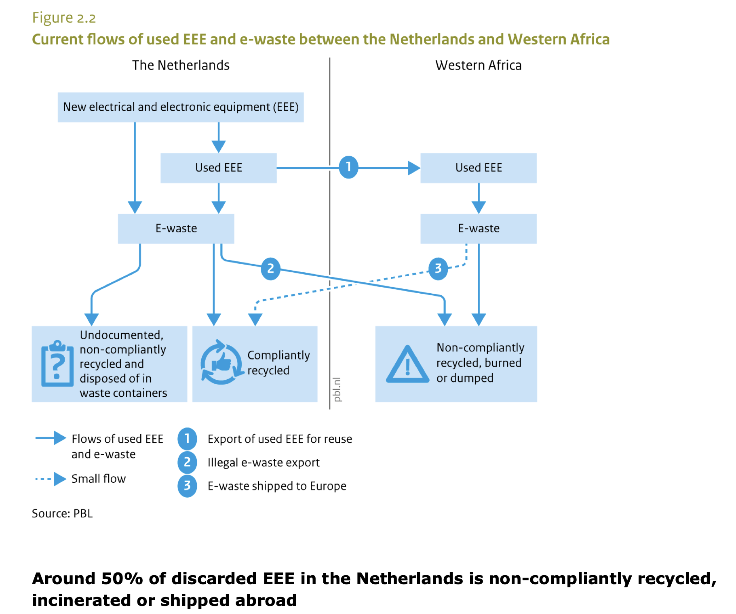

**Phillips Supply chain- Sustainability report**

<https://images.philips.com/is/content/PhilipsConsumer/Campaigns/CO20180412-Assetlibrary/Supplier-Sustainability-Performance-SSP-brochure-v181026.pdf>

<https://www.philips.com/a-w/about/environmental-social-governance/downloads.html>

**Waste Shippment EU-Comission**

<https://environment.ec.europa.eu/topics/waste-and-recycling/waste-shipments_en>

**Interpol Electronic Waste and Organized Crime, Assessing the Links**

→ gives overview on illegal actors / very good, literature review and great background information

<https://www.google.com/url?sa=t&rct=j&q=&esrc=s&source=web&cd=&cad=rja&uact=8&ved=2ahUKEwjatt3Px_KLAxUXBNsEHXHZOkoQFnoECCsQAQ&url=https%3A%2F%2Fwww.interpol.int%2Fcontent%2Fdownload%2F5174%2Ffile%2FElectronic%2520Waste%2520and%2520Organized%2520Crime%2520-%2520Assessing%2520the%2520Links.pdf&usg=AOvVaw1CbcBBCb_cDbdhIzJR2kWi&opi=89978449>

**Critical raw materials in Li-ion batteries**

<https://www.innoenergy.com/uploads/2023/01/critical-raw-materials-in-li-ion-batteries.pdf>

To Contact:

<https://www.circular.industries/contact.html>

<https://landbell-group.com/how-can-we-help-you/>

Umnicore

<https://www.epea.com/en/news>

Metabolics

Scope of our research-

Important for Energy and mobility transition!

Most important element

**E-waste**

Company: **Top E-bike manufacture of the Netherlands:**

<https://www.dynem.in/blogs/top-e-bike-manufacturers-in-the-Netherlands>

Product: E-bike **Batteries -> look into e-bike battery suppliers**

Component: Batteries- type of Battery: Lithium Ion Battery

Characteristic: most efficient

CRM: Lithium, Cobalt, Nickel

Hazadeous waste component.

Lithium Ion Batteries: ->Lithium+Cobalt

Sodium Ion Batteries: Interesting as sustainable alternatives

**Questions:**

-Ion Batteries have a long life cycle (how long)

-What waste cycle does exist?

**Analysis of Ecological Footprint of Lithium Ion Battery**

[Lithium-Ionen-Akkus: Das sollten Sie darüber wissen](https://www.ingenieur.de/technik/fachbereiche/energie/lithium-ionen-akkus-das-sollten-sie-darueber-wissen/)

[Recycling chains for lithium-ion batteries: A critical examination of current challenges, opportunities and process dependencies - ScienceDirect](https://www.sciencedirect.com/science/article/pii/S0956053X21006267)

[Recycling von Lithium-Ionen-Batterien wird in Europa stark zunehmen - Fraunhofer ISI](https://www.isi.fraunhofer.de/de/blog/themen/batterie-update/recycling-lithium-ionen-batterien-europa-starke-zunahme-2030-2040.html)

Aufbau Batavus: <https://www.studeersnel.nl/nl/document/hogeschool-inholland/p7-project-supply-chain-managementplan/werkgroep-uitwerkingen-1supply-chain-managementplan-project/122524>

# Battery Recycling Supply Chain Analysis

<https://www.nrel.gov/transportation/battery-recycling-supply-chain-analysis.html>

[**https://aquametals.com/recyclopedia/what-exactly-is-black-mass/**](https://aquametals.com/recyclopedia/what-exactly-is-black-mass/)

**To do´s:**

* **Choose a company**
* **Map out a system (Batterie universe- law, power, environmental impact, consumer relevance, DESTEP, economics)**
* **Lithium Ion Battery verstehen( Characteristics, lifecycle, usage, production, relevant regulations, components)**
* **Write down Question for Interview**
* **Write a report on how we worked on this problem (our process, including difficulties and what tips from our mentor that helped us)**

**recycling of lithium / ecoban**

**batteries**

**tesla**

**ttt mining ruanda mine tilings**

**Interview next week:**

**Challenges in the industry, best practices, government requirements, corporate side of thinking**

**We are in sensing use theory U for our project; where are we?**

**Meet stakeholders to map out the problem**

**keep it semistructured; do research, go in own experience; have you had a n experience of disruptions**

**soon pick a poison,**

**separate dismantle batteries, materials design, design for recycling**

**TU Delft**

**DESIGNING / DISMANTLING**

**lithium is getting in recycling time**

**nordvolt look into how to use batteries without lithium**

**are you getting recycled material/ feasibility in the supply chain**

**where is the possible disruption?**

Communication with suppliers incentivizes work with them; paper, makes the difference in disruption

supply/mineral perspective

**3 solution, good idea of the problem**

**2-minute pitch of what we are doing, suggest where there might be issues**

**laws, new market**

**How would it help the company→ reputation& financials / in changes**

**already prepared for disruption**

**how does the market work?**

**Learn to do the hard things, what sets you apart/ bring a different perspective what**

**excitement**

**Interview Questions:**

### **2. Market Intelligence & Industry Trends *(Sensing Emerging Patterns)***

* **"From your market research, what are the most disruptive trends in battery recycling (e.g., direct recycling, second-life applications)?"**
* **"Which regions or markets show the most potential for scaling e-bike battery recycling, and why?"**
* **"How do fluctuating mineral prices (Li, Co, Ni) impact Umicore’s recycling profitability?"**

**CATEGORIES:**

* **Market Dynamics**
  + ***“How do you see the demand for recycled e-bike battery materials evolving?”***
* **Policy & Business Models**
  + ***“What policies would most boost e-bike battery recycling profitability?”***
* **Umicore’s Strategic Vision**
  + ***“Where does Umicore see the biggest untapped opportunity in small-format battery recycling?***

1. **From Umicore’s data, what’s the *current* break-even point for recycling e-bike batteries vs. mining virgin materials?" *(Probe: Is it volume, chemistry, or policy-dependent?)***

**"How has the EU Battery Regulation (e.g., 2027 Li recovery targets) *directly* changed Umicore’s recycling process?**

**What *one* policy change would most boost e-bike battery recycling rates?" *(Probe: Stricter producer liability? Tax incentives?)***

**Are there conflicts between EU recycling targets and today’s *actual* industry capacity?"**

#### **Closing (2-3 mins)**

**"What’s the most surprising insight you’ve learned about e-bike battery recycling’s future?"**

**"How has the EU Battery Regulation (e.g., 2027 Li recovery targets) *directly* changed Umicore’s recycling process?"**

**economic incentive, geopolitical tension, countries, dependencies, precious metals refining, recycling, research driving comany, scope**

**who are the competitors', bottlenecks?**

**always lare companies,easier ehen colleagues**

**competitors, copper for escab but heir differientiaion is variety of materials, individual competitors, but not as broad**

**be as essifient as your focus**

**arubis bollledon competitors**

**production scap. bbyproducts →**

**annatoling cintract**

**pirol flow sheets**

**65 percent no intermediaate volume**

**go to volume, fridges … but valuable metals are more valuable**

**ambition should not be**

**value / volume perspective**

**inv´centivice. experimente ale´rasy accessibke,**

**mobile infrastructure is already in place, moving**

**biggest pain, collection,**

**transport legislation, indufficient collection**

**unitech report ewaste from the electronics**

**explosion of solar waste,**

**conflicting etal values**

**nit sales driven–Y supply driven, not purchase on the market, more like offering recycling service , pay fee and get materiali back**

**volume of shipments,**

**how does the shipment work ?**

**treatment charges**

**hydrogen**

**confident in own knowledge,**

**what are people not saying**

**you always should have**

**whats nextt,skills you have as an adult**

**how to deal with people outside of your corner**

**keep those friendships!!**

**benjamin sprector tu delft professor**

**the hague center for strategic materials**

**frauenhofer institut partners with windehsiem**

**forst guaard frauenhofer institut**

**look at policies from asien perspective, why is china and japan working**

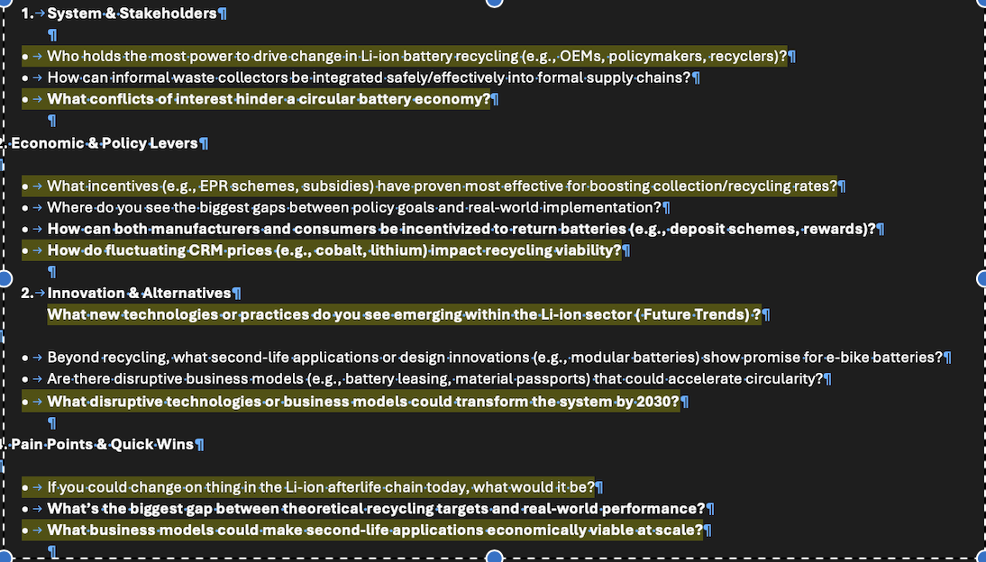

Interview with Hannah Jung TNO

**Main insights:**

-E waste is labeled as second hand product which is waste to western country and gets shipped to african countries under the umbrella of selling it as product of need to the the nations - therefore waste shipping is legally possible

- Product get used in african nation until the point of no more after life value

- PV Instalation

- E - waste in africa doesn't get recycled instead it get stored, bcs of missing infrastructure.

-No processing systems

- Increase E waste masses with increased usage of electronics ( batteries)

-In the southern hemisphere the market are the drivers of change and in the northern hemisphere policymakers and directors have the most systematic power

-Reusage of product happens on a bigger scale in african countries vs. in northern countries

-Change is driven by market prices

-Investing in preprocessing would open new job markets

-waste compensation

**General hurdles:**

-Collection rates barrier and constant flows of E- waste

-Recycling capacity is just a hurdle

- Recycling capacity is very low and the lowest point of the R-Letter

-Disassembling processes and sorting process are cost and labour intensive

- Geopolitical interest is problematic

**Possible Solution:**

- New Markets -> Closing the loop ( Research needed)

-Collection business

Bridging the Gap between sustainability and commercial benefits

-Focus on the Doers

**Note:**

**-Scale of battery production and invention influences recycling process and availability in the future.**

**-Relevance of recycling is increasing due to geopolitical tensions and power dynamics. Dependence of internal material flow will become more relevant**

**Problem product inflow:**

Incentive in collecting bcs of resource scarcity , resources that are inflow in product can be retrieved through recycling , create a business incentive around that.

**To look into:**

EPR

Stichting Open

Stibat

Closing the Loop - waste compensation

National Material Observatory from TNO

[Nederlands Materialen Observatorium | TNO](https://www.tno.nl/nl/duurzaam/duurzame-ondergrond/geologische-dienst-nederland-duurzaam/nederlands-materialen-observatorium/)

Nederlands Materialen Observatorium | TNO

Het NMO gaat samen met het bedrijfsleven en andere partners de waardeketens van kritieke grondstoffen voor Nederland in kaart brengen en monitoren.

**Interview Thomas Fischer**

***Wie bewerten Sie die Wirtschaftlichkeit von Second-Life-Projekten für E-Bike-Batterien im Vergleich zum direkten Recycling?"***

***Wenn Sie eine Sache im Lebenszyklus von Lithium-Batterien sofort ändern könnten – was wäre es?"***

### ***1. Gesetzgebung & Politik (EPR & Compliance)***

1. ***"Welche EPR-Modelle für Lithium-Ionen-Batterien haben sich in paneuropäischen Rücknahmesystemen als am effektivsten erwiesen – und wo scheitern aktuelle Regelungen?"***
2. ***"Wie könnte die Gesetzgebung Hersteller besser dazu animieren, Batterien für die Kreislaufwirtschaft zu gestalten (z.B. Modularität, Kennzeichnung), ohne Innovation zu behindern?"***
3. ***"Wie bewerten Sie den ‚Battery Passport‘ der EU-Batterieverordnung? Wird er Recyclingquoten spürbar verbessern?"***

### ***2. Stakeholder-Management (NGOs, Behörden, Medien)***

1. ***"Welche Interessenkonflikte zwischen Recyclern, Herstellern und NGOs müssen Sie am häufigsten vermitteln – und wie?"***
2. ***"Wie kommuniziert man technische Recycling-Herausforderungen an politische Entscheidungsträger, ohne Greenwashing-Vorwürfe zu provozieren?"***
3. ***"Welche Medienstrategien fördern die Rückgabebereitschaft von Verbrauchern, ohne negative Reaktionen auszulösen?"***

### ***3. Betriebliche Realitäten & Führungserfahrung***

1. ***"Welche KPIs sind jenseits der reinen Recyclingmengen entscheidend, um echte Kreislaufwirtschaft zu messen?" (Aus Ihrer Erfahrung als Vorstand eines Rücknahmesystems)***
2. ***"Was war die überraschendste Erkenntnis beim Aufbau von Sammelsystemen in verschiedenen europäischen Märkten?"***
3. ***"Wie balancieren Sie kurzfristige Compliance-Anforderungen mit langfristigen Investitionen in die Kreislaufwirtschaft, wenn Sie Unternehmen beraten?"***

### ***4. Zukunftsorientiert***

1. ***"Welches Element des aktuellen EPR-Rahmens für Batterien würden Sie neu gestalten – und warum?"***
2. ***"Welche aufstrebende Technologie (z.B. Blockchain-Tracking, KI-Sortierung) wird das Batterierecycling in 5 Jahren am stärksten verändern?"***
3. ***"Welches unterschätzte Politikmodell oder Geschäftsmodell aus anderen Branchen könnte das E-Waste-Management revolutionieren?"***

### ***Abschließende Einsicht***

1. ***"Was würden Sie heute anders machen, wenn Sie ein Rücknahmesystem von Grund auf neu starten würden?"***

***Rationale (Begründung der Fragenauswahl):***

* ***Governance-Erfahrung nutzen (Fragen 7, 13)***
* ***Verhandlungsgeschick analysieren (Fragen 4, 5)***
* ***Praktische Betriebserkenntnisse (Fragen 8, 9)***
* ***Zukunftsweisend (Fragen 10-12)Tonfall: Präzise, aber einladend für praxisnahe Antworten. Die Fragen sind direkt anw…***

***Problem:***

1. *Mining is still accessible and cheaper than recycling, making recycling a less attractive option ( incentives factor) + Recycling is not high on the R- Latter (Sustainability factor)*
2. *Collection rates are not high enough for mass recycling and profitability*

*Problem: Consumer responsibility -> lack of awareness + misbelief of responsibleness lies only in procedures hands -> result of Capitalistic system*

*3.Complexity in regulation monitoring and execution for businesses (keine Tracability and no system place) -* ***Green Compliance Burden Disparity***

***What is the term for this following situation of inequality within the emerging sustainability regulations frocing companies to invest time and recourcess and sustainable practice monitioring and reporting. While big compnaies might have more money and people to do the work (small investmate to adeer to the regulations) Vs small companies being overhelmed due to the lack of recources in time, money and personal, leading them to lose profit.***

*This describes how smaller businesses struggle disproportionately compared to larger corporations when complying with new environmental and sustainability regulations. Larger firms have dedicated teams, financial resources, and economies of scale to absorb compliance costs, while smaller businesses face higher relative costs, administrative strain, and potential competitive disadvantages.*

*4. Inhomogeneity of waste management processes*

*5. Constantly new emerging technologies -> and no recycling processes for them in place*

*6. There are different communication plattforms for copper and*

*nicht übergereifen genung und nicht einheitlich*

*Circular economy act - strives to solve the problem in 5 years*

*7.*

***Transition Period is our Problem!***

***Long term Trend- Future goes to Circultarity***

***Push factor: Goal and incentives for changing to circular economy: Be independent from Geopolitical power structures within the supply chain by using recycled materials already circulating***

***Emerging market for Lithium bcs of for all collected materials that are being processed, a market needs to there there to reintegrate it into the value chain ->in correlation with price flutions in the market of CRM prices***

***Trend goes to circular economy - companies are being pushed through the outside forces in society and environment to switch to sustainable practices***

* ***Polluter pays principle:***
* ***T****he "Polluter Pays Principle" (PPP) is an environmental policy framework where the party responsible for pollution bears the costs of its mitigation, cleanup, and damages. It aims to internalize environmental externalities, ensuring that companies or individuals account for the ecological harm they cause.*

***-Caution of inequality***

***Convenience of no consequences for actions***

***Our Ideas for solutions:***

* **Possible Solution:**

- New Markets -> Closing the loop (Research needed)

-Collection business

Bridging the Gap between sustainability and commercial benefits

-Focus on the Doers

* Take back programms (pains)

*3.Complexity in regulation monitoring and execution for businesses (keine Tracability and no system place) -* ***Green Compliance Burden Disparity (what can relieve this pain)***

**After Life:**

* Who collects the materials?
* Where do the materials Go to (Companies)
* Who dismantles the products
* What happened to the Battery components
* Where does the Lithium go Afterwards - how does it enter back into the system?
* What is the value of the Lithium afterwards

Map relevant stakeholder in the Afterlife cycle of a lithium battery of a specific product for example- the afterlifecycle of müller & Riese

***To do see Chat:***

* ***Use AI for research and systems mapping***
* ***Make a Prototype –What***
* ***Why of the pain–What is our story for our Business (Ausarbeitung)***
* *feasibility study ?*
* ***How- Who benefits and how will people use it***

**Chris Consulting Cal l-03.04.2025**

* **Problem is bigger than Marketfit (Supply chain need)**
  + **Project demand and supply**
  + **Problem > market fit (supplychain need)**
  + **Another way of saying market fit is to project the supply and demand of lithium Vs the amount of lithium (in raw resources) and then the potential that we could fill (need) with recyclei g**
  + **But why are we not filling this need of lithium ? (Why Arnt we recycling) (Are we dumb?) No its because (paperwork or people dont know how or there is no money in it or another reason see interview)**
  + **And the you come along and say solution : we will build an app or a new procedure to fix this problem of not recycling**
  + **EXPl: reduce paperwork**
  + **But it could be anything**
  + **You can do a mock up and test with people**

**So consider that- Geopolitical**

**Problematic:**

* **What countries have currently the best advantages using ai freely**
* **And look 4 that news articles about wars over lithium**

[**https://oilprice.com/Metals/Commodities/Russias-Control-of-Ukrainian-Lithium-Mines-Threatens-Europes-Green-Energy-Shif.html**](https://oilprice.com/Metals/Commodities/Russias-Control-of-Ukrainian-Lithium-Mines-Threatens-Europes-Green-Energy-Shif.html)

**Russia Takes Control of Ukrainian Lithium Mines | OilPrice.com**

**Russia's capture of Ukraine's lithium deposits threatens Europe's green energy transition and highlights the strategic importance of critical minerals.**

**bcs those will likely experience the fastest progress right?**

**Also trump + lithium and Ukraine is a big thing..**

**Basically saying, unless you give us those minerals... We won’t help you anymore.m**

**Yes. Ask deepseek (in the openwebui)**

[**https://m.youtube.com/watch?v=kBNjbgDvvdg**](https://m.youtube.com/watch?v=kBNjbgDvvdg)

**- YouTube**

**Enjoy the videos and music you love, upload original content, and share it all with friends, family, and the world on YouTube.**

[**https://m.youtube.com/watch?v=r5_34YnCmMY&pp=ygUWU3Rvcnl0ZWxsaW5nIHdpdGggZGF0YQ%3D%3D**](https://m.youtube.com/watch?v=r5_34YnCmMY&pp=ygUWU3Rvcnl0ZWxsaW5nIHdpdGggZGF0YQ%3D%3D)

**- YouTube**

**Enjoy the videos and music you love, upload original content, and share it all with friends, family, and the world on YouTube.**

[**https://m.youtube.com/watch?v=R9OHn5ZF4Uo&pp=ygUZSG93IGRvZXMgYWkgd29yayBncHQgZ3JleQ%3D%3D**](https://m.youtube.com/watch?v=R9OHn5ZF4Uo&pp=ygUZSG93IGRvZXMgYWkgd29yayBncHQgZ3JleQ%3D%3D)

**- YouTube**

**Enjoy the videos and music you love, upload original content, and share it all with friends, family, and the world on YouTube.**

**Maxime:**

**Everything is a assumption:**

**Emerging market + a lot of uncertainty**

**Make our leading questions clear!**

**What are the growing markets**

**What regulations are we talking about**

**Where do we close the gap:**

**Define more what the AI Actually does:**

**-Specific actions**

**Weaknesses:**

-Dealing with senttitve data

-Privarcy ect.

-Prepare business for just being compliant now !

-

Mention what we have looked into

-sourcing difficulties

-Clarity and visibility in the waste streams

a.

b.

c. create batteries in the market so that they are recyclable

Fitting ans suefull for the market

What if - 1. step of solving this big issue?

Industry is scattered- creates waste and problems

Unused potential

Highlight unused potential:

clarity !!!!!!!

Why it makes sense for where we are at

Future outlook

Qurstion mark

Assumption

Deeper analysis of collaboration and waste streams

Overview of the state of the market right now-

**Li-monti**

1. What is our role in our business→ What is our job, and what value are we offering

* manolie& leoni = ceo/**project manager**/change manager
* we are the “glue” between 2 parties/ A: needing something & B: has the solution / we= glue= bridge between a&b
* we manage the process between hired stakeholders,legal experts, marketing, consultqants? with support of AI

Values:

1. **What pains are we covering**

* paperwork general
* Green Deal regulations
* lack of communication
* green compliance disparity
* Recyclers lack the ability to collect goods
* Increased need for recycling, complex problems/ see problem statement 1-3 other document

1. What is our service that people can find on your website, and why is it valuable?

* we make better deals than the competition

inspired by manolies network platform

Differentiation point to be researched

social media for recycling? job opportunities, rasier and tracable supply chains, delivery of goods

1. Simple at straightforward to use ( with whom do we work? ) → Marketing, Law (Consultants), AI, yes but target audience: SMEs, Recyclers
2. The aim is to save time and increase collection and recycling rates, provide people with jobs and productivity, and ensure clarity and compliance.

We bring people together to work on the same problem!

Passion for resources, CRM, ensuring innovation, and reducing trash

Profitability:

<https://www.canva.com/design/DAGkEua-UsQ/mq7dxmdRv3Y1WElT1LRjoA/edit>

Outline for Presentation

Problem (already in document, now just cover numbers and get study)

Solution (our approach)

Business Case

Economic benefits/ profitabiulity/ Feasibility Study

Sustainable Future/ Impact

Sources   
LinkedIn QR code

importance of legal person?

inform more! reseach/ hard facts/ bring it together!

**Work Session 28.05.2025 Mandarine de gg**

**What?**

With an extended need for recycling companies in the next coming decades the question arises, how will companies who wish to enter the recycling business navigate, regulations, profitability and collection as well as waste management of the upcoming waste waves that hold valuable raw materials. Which experts will need to work together and how will they be able to find each other quickly and efficiently. Which project emerges in face of these questions and upcoming challenges.

**What we know from research and past interviews:**

* ***Although recycling is crucial for sustainability, mining will continue to play a central role in providing minerals for Li-ion batteries as long as the rate of new batteries being manufactured and entering the market is greater than the rate of batteries reaching end-of-life and leaving the field (***[***https://www.waste360.com/waste-recycling/the-role-of-battery-recycling-in-the-circular-economy-supply-chain-logistics-and-profitabilit***](https://www.waste360.com/waste-recycling/the-role-of-battery-recycling-in-the-circular-economy-supply-chain-logistics-and-profitabilit)***).***

**Why Recycling is a Win-Win**

* Recycling lithium-ion batteries offers benefits that go far beyond waste reduction:
* Economic Opportunity: The global battery recycling market is expected to reach $23 billion by 2030, creating jobs and boosting local economies.
* Energy Security: By recovering materials domestically, countries can reduce their reliance on imported raw materials and build more resilient supply chains.
* Sustainability Leadership: Companies and governments that invest in recycling now will be leaders in the global push for sustainability.
* Recycling can recover up to 96% of these critical materials, reducing the need for new mining and ensuring a steady supply for future battery production.
* By 2030, the number of discarded EV batteries alone is expected to reach 11 million metric tons annually. Without proper recycling infrastructure, managing this waste will be a monumental challenge.( see linked in source below)
* <https://www.linkedin.com/pulse/e-waste-emergency-why-lithium-ion-recycling-critical-sustainable-vwndf/>

<https://www.waste360.com/waste-recycling/the-role-of-battery-recycling-in-the-circular-economy-supply-chain-logistics-and-profitability>

**The Project**

We propose a 20 year project where recycling centers, networks and infrastructures will be built.

**Immediate Goal**

-Network

-Matchmaking system

-Event

-General Update/Info Hub

-Your Partner: Compliance, Recyclers, Logistics, Marketing, Engineers

**Long term next 20-50 years**

Transition Plan Draft:

Stage 1 of the Project:

Stage 2 of the Project:

Stage 3 of the Project:

The Goal of our initiatve is to…

* we manage the process between hired stakeholders,legal experts, marketing, consultqants? with support of AI
* Why is E-waste recycling important, why should it matter to you? The future of the E-waste recycling market + where it is moving towards

**Source:**

<https://www.businessresearchinsights.com/market-reports/battery-and-other-e-waste-recycling-market-111725#menu1>

<https://www.linkedin.com/pulse/e-waste-emergency-why-lithium-ion-recycling-critical-sustainable-vwndf/>

* Recycling can recover up to 96% of these critical materials, reducing the need for new mining and ensuring a steady supply for future battery production.
* By 2030, the number of discarded EV batteries alone is expected to reach 11 million metric tons annually. Without proper recycling infrastructure, managing this waste will be a monumental challenge.

### **Why Recycling is a Win-Win**

Recycling lithium-ion batteries offers benefits that go far beyond waste reduction:

* Economic Opportunity: The global battery recycling market is expected to reach $23 billion by 2030, creating jobs and boosting local economies.
* Energy Security: By recovering materials domestically, countries can reduce their reliance on imported raw materials and build more resilient supply chains.
* Sustainability Leadership: Companies and governments that invest in recycling now will be leaders in the global push for sustainability.

<https://www.waste360.com/waste-recycling/the-role-of-battery-recycling-in-the-circular-economy-supply-chain-logistics-and-profitability>

### **Refined Problem Statement and Solution Approach (Conclusion of Work Session)**

In face of the Energy Transition and the new growing market for the recycling sector. Especially in face of resource scarcity, Geopolitical tension and high market dependencies and ecological concerns, recycling becomes a very important change point for a proper and green energy transition.

Therefore after analysing major pain points for recycling companies, talking to waste flow managers and compliance execution companies we have noted the following pain points:

### Low collection rates and inconsistent flows of e-waste hinder proper recycling.

### Recycling capacity is limited and often considered the weakest point within the “R-strategies” (e.g., reduce, reuse, recycle).

### Disassembly and sorting processes are both labor- and cost-intensive.

* insufficient infrastructure for recycling

**Potential and relevance:**

### The scale of battery production and innovation will influence future recycling capabilities and system development.

### Geopolitical tensions and shifting power dynamics are increasing the relevance of recycling. Dependence on internal material flows will become more critical for national resilience and autonomy

* Predicted numbers of E-waste in 20-40 years - ()

Our Goal and Service:

**We recognize**

A: Compliance

B: Collection

C: Infrastructure- Capacity

D: Network ? ( Missing people and collaboration within the Recyclers)

E: Job Opportunity that is not replacable by AI only 20-40 years from today!

Who can benefit from it:

Economic Value futures research: *Global battery and other e-waste recycling market size, valued at USD 864.44 billion in 2024, is expected to climb to USD 3325.41 billion by 2033 at a CAGR of 15.9% during the forecast period.* ***Source:****https://www.businessresearchinsights.com/market-reports/battery-and-other-e-waste-recycling-market-111725#menu1*

The transition is unavoidable, Other countries like China and Russia have the opper hand when it comes to CRM and the technologys of the future.

Therefore, it would be smart to invest wisely now! For the future

BCS who can imagine a world without technology anymore.

We as Project manager will initiate a Project with a different pilot phases in the different sectors, within the next 10 year to collect data on how each sector can benefit from the transition and collaboration support within the Recycling industry.

**Li-monti will- here name exact activity:**

**The Project**

We propose a 20 year project where recycling centers, networks and infrastructures will be built.

**Immediate Goal**

-Network-> build a network for different recyclers and people who want to join the industry to connect them on a global level and share new trends and emerging actions to take as a collective in the recycling sector.

We project manager will analyse common pain point, needs, best practices and actions points for the future and based on this information draft new project and initiative around them, promising a problem solving sector! Solutions found to a collective problem, will serve the collective.

Our Approach should be applicable for diverse recylers in some type and form

-Matchmaking system we link you with your:-Your Partner: Compliance, Recyclers, Logistics, Marketing, Engineers

We match the right services givers with the rights costumers. It could be Collection Sevices with recycling hubs or , complience firms with new recyclers or Marketing agents with recycling companies, website builders ect.

We will provide everything that a company needs service or employer wise and reduce the amount of research for the companies.

-Event

We will link and showcase relevant events on our platform

-General Update/Info Hub

**Long term next 20-50 years**

Transition Plan Draft:

Stage 1 of the Project:

Stage 2 of the Project:

Stage 3 of the Project:

Why people should invest in us:

-Relevance of the now for a better tomorrow, it requiers research and action at the same time

- Cost

Revenue Model:

Feasibility:

Impact:

Risk Factor:

**AI Summary:**

**Project Summary: E-Waste Recycling Infrastructure Initiative**

**Overview:  
 This is a 20-year project aimed at building a robust network and infrastructure for e-waste recycling. The goal is to connect key players—recyclers, compliance officers, logistics providers, marketers, and engineers—through a centralized system supported by events, matchmaking tools, and an information hub. The project also includes a long-term vision spanning 20–50 years to transition to a more sustainable circular economy for electronic waste.**

**Immediate Goals:**

* **Establish a network of stakeholders.**
* **Create a matchmaking system to connect relevant partners.**
* **Host events to build awareness and collaboration.**
* **Launch a central information and update hub.**
* **Collaborate with partners across compliance, recycling, logistics, marketing, and engineering.**

**Transition Plan (Draft):**

* **Stage 1: Build foundational partnerships and launch the platform.**
* **Stage 2: Develop and implement infrastructure and matchmaking tools.**
* **Stage 3: Scale operations and refine systems with support from AI, managing all stakeholder interactions—legal, consulting, marketing, and more.**

**Why E-Waste Recycling Matters:  
 E-waste is one of the fastest-growing waste streams globally. Recycling it properly helps recover valuable materials, prevents environmental damage, and supports a circular economy. The e-waste recycling market is evolving quickly, with major growth expected due to policy changes, technological advancements, and rising environmental awareness.**

**VALUE PROPOSITION LI-MONTI**

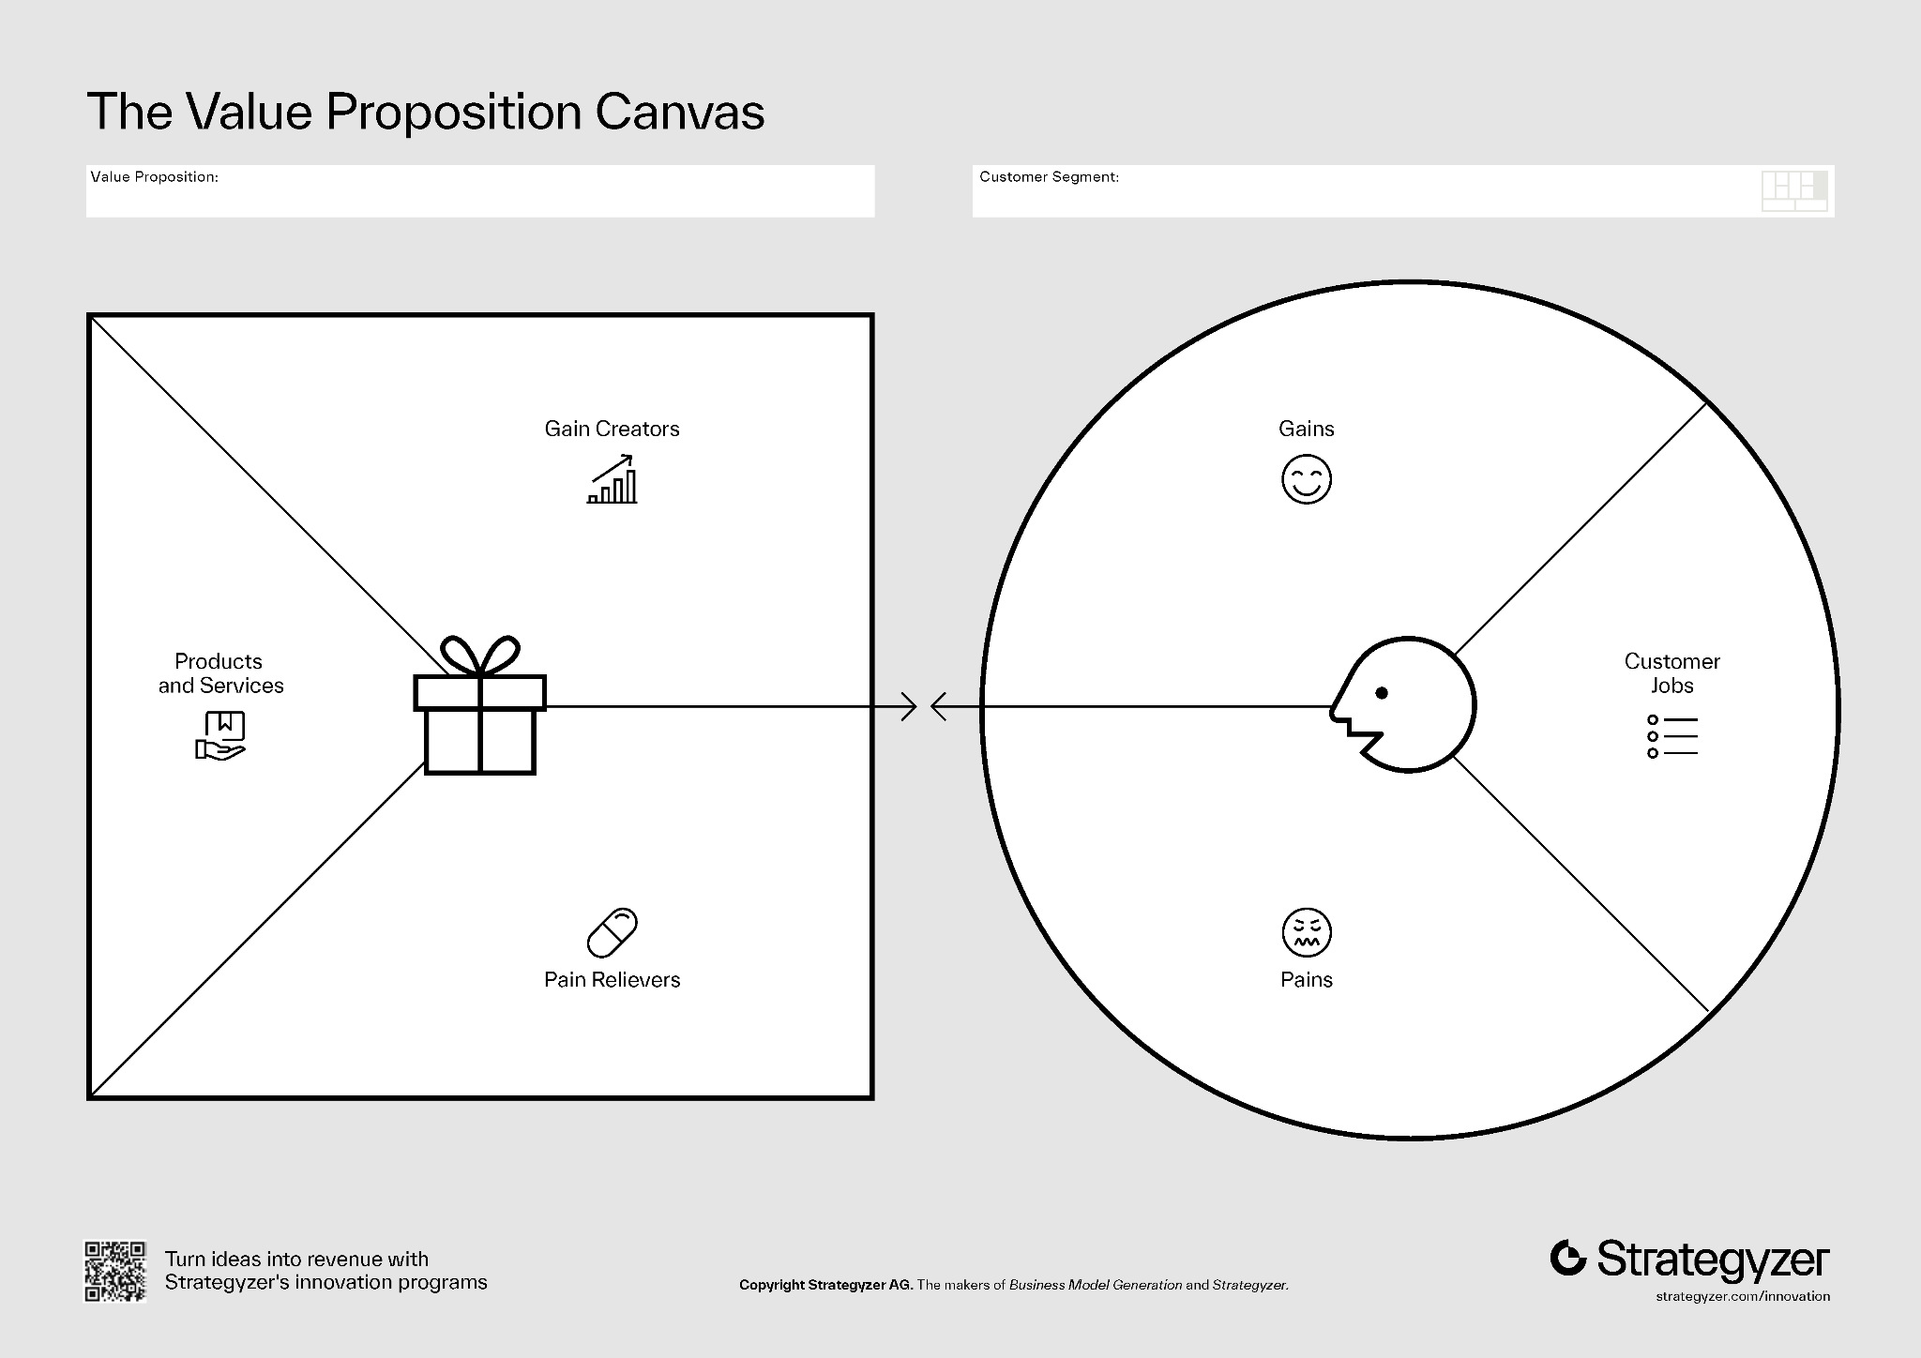

**Advice**: Try to write your value proposition like this:

“We help [target group] solve [specific pain] by offering [solution], so they can [benefit].”

We Help **SMI Lithium Recycling Companies** solve (Complience disparity ) by offering (Network, Compliance guidance and Information), so they can (Save time, which is money and fines).

**Leading Question from Cancut:**

* What specific administrative task takes up the most time or resources?
* How do they currently deal with this?
* What would they pay to have that problem solved?

**Pain Point:**

## Key Administrative Burden for SMI Lithium Recycling Companies

Most Time-Consuming Administrative Task:  
For small and medium-sized enterprises (SMIs) in the lithium recycling industry, the administrative task that consumes the most time and resources is *sustainable regulation compliance*. This includes:

* Tracking and documenting the entire lifecycle of lithium-ion batteries (LIBs), from collection to recycling and final material output.
* Ensuring compliance with diverse and evolving local, national, and international regulations regarding hazardous waste, environmental protection, and extended producer responsibility.
* Managing traceability and reporting requirements, such as detailed record-keeping, data entry, and submission of compliance documentation to authorities.

How They Currently Manage Compliance:

* Many SMIs rely on manual processes, spreadsheets, and fragmented digital tools to track battery flows, record compliance data, and generate regulatory reports.
* They often assign significant staff time to interpret new regulations, update procedures, and ensure documentation is audit-ready.
* Some companies attempt to automate parts of the process with custom or off-the-shelf compliance management software, but integration challenges and lack of industry-specific solutions often limit effectiveness.

Willingness to Pay for a Solution:

* While specific pricing data is scarce, interview insights and industry reports suggest SMIs would pay a significant premium for a solution that:
  + Automates lifecycle tracking and compliance reporting,
  + Reduces manual labor and risk of non-compliance,
  + Keeps pace with regulatory changes.
* The willingness to pay is driven by the high cost of compliance failures (fines, reputational damage, business interruption) and the substantial labor hours currently required. Solutions that demonstrably reduce these risks and costs could command prices in the range of several thousand to tens of thousands of dollars per year, depending on company size and complexity.

## Supporting Literature and Insights

Academic and Industry Papers:

* *Current Challenges in Efficient Lithium‐Ion Batteries' Recycling* (2022) provides a comprehensive overview of the regulatory and administrative burdens faced by recyclers, highlighting the complexity of compliance and the inefficiencies of current manual approaches.
* The *IEA’s 2024 report on Recycling of Critical Minerals* emphasizes the need for harmonized, transparent compliance systems and the growing administrative load as regulations proliferate globally.
* The *CSIRO Report: Australian landscape for lithium ion battery recycling and reuse in 2020*discusses the economic and regulatory pressures on recyclers and the need for technology-driven compliance solutions.

Interview Insights:

* Industry interviews (summarized in sector reviews) reveal that compliance management is a universal pain point, with companies expressing frustration over the lack of standardized digital tools and the resource drain of manual reporting.
* There is strong interest in digital platforms that can centralize compliance data, automate reporting, and adapt to new regulations, with SMIs indicating they would pay for such solutions if they could demonstrate clear ROI in terms of labor savings and risk reduction.

## Summary Table

| **Administrative Task** | **Current Approach** | **Pain Points** | **Willingness to Pay for Solution** |
| --- | --- | --- | --- |
| **Regulatory compliance (sustainability, traceability, reporting)** | **Manual tracking, spreadsheets, basic software** | **Labor-intensive, error-prone, high risk of non-compliance** | **High, especially for automated, adaptive solutions** |

## Conclusion

Sustainable regulation compliance is the most resource-intensive administrative task for SMIs in the lithium recycling sector. Current approaches are inefficient and costly, driving strong demand for automated compliance solutions. Industry literature and interviews confirm that SMIs would pay a premium for tools that reduce manual work, ensure ongoing compliance, and adapt to regulatory changes.

**Current Situation**

| **Compliance Task** | **Typical SMI Approach** | **Tools Used** |
| --- | --- | --- |
| Record-keeping & documentation | Manual entry, spreadsheets, basic databases | Excel, custom templates |
| Regulatory reporting | Periodic manual report compilation | Word, PDF, online portals |
| Traceability & labeling | Physical labels, QR codes (EU) | Label printers, BMS |
| Staying updated on regulations | Internal monitoring, third-party services | Newsletters, consultants |

SMIs are under increasing pressure to automate and streamline these processes due to rising compliance demands and the risk of severe penalties for non-compliance.

**Our Service/ Change Proposal:**

1. What does the core product offering looks like ?

**Income Source:**

1. how do you intend to make money? explore and test at least two different monetization strategies.

### 

### 

### 

### 

### 

### 

### 

### 

### 

### 

### 

### 

### 

### 

### 

### 

Li-Monti-Energy Transition Management Initiative

### **Li-Monti's Value Proposition**

We help recyclers, circularity innovators, and public sector actors solve systemic barriers in battery recycling—such as lack of collaboration, funding, and time to act by offering a project-based platform that maps pain points, connects relevant stakeholders, and turns ideas into supervised pilot projects, so they can co-create scalable, impactful solutions that accelerate a truly circular energy transition.

Our Philosophy: Montessori- Help mir mi

### **Li-Monti's Unique Selling Point**

**Li-Monti is the first action-oriented collaboration platform that transforms overlooked system pain points in battery recycling into concrete, supervised pilot projects—by connecting small and mid-sized recyclers with the right minds, resources, and partners across sectors.**

Unlike policy think tanks or isolated recycling initiatives, **Li-Monti combines data mapping, matchmaking, and project management** in one place—bridging the gap between knowledge and implementation at scale.

## **Li-Monti: A Platform to Power Solutions in E-Waste and Battery Recycling**

### **The Problem**

The energy transition depends on better recycling systems, especially for lithium-ion batteries and electronic waste (e-waste). But today, the sector faces real bottlenecks:

* Collection rates are low and inconsistent
* Disassembly and sorting are labor-intensive and expensive
* Recycling infrastructure is underdeveloped
* Compliance is complicated and fragmented
* Small and medium-sized recyclers (SMEs) don’t have time, capacity, or money to solve these issues alone
* Governments often ignore or delay action on these problems

And yet—we **all want sustainable batteries and a circular economy**, right?

### **Our Response: Collective Action, Not Just Connections**

**Li-Monti** is not just another digital network or information platform.  
It’s a **project-driven action space** where people with **skills, motivation, and solutions** can tackle the pain points that matter—but that no one else is addressing.

### **🎯 Our Goal**

To **connect pressing recycling challenges with the people and resources needed to solve them.**

We do this by:

* **Mapping sector-wide problems** through interviews, data, and research
* **Identifying pain points** that governments overlook and SMEs can’t solve alone
* **Bringing together project managers, experts, engineers, students, and creatives** who want to contribute
* **Launching real-world projects** to test and implement solutions
* **Supervising and guiding** these projects through our platform

### **🛠️ What the Platform Offers**

1. **Problem Mapping + Data Collection**We gather insights directly from recyclers, waste managers, compliance firms, and local actors. This forms the living foundation of our action plan.
2. **Collaboration Engine**We match problems with project teams—linking SMEs with people who want to contribute: from compliance experts to designers, marketers, developers, and sustainability students.
3. **Project Launchpad + Supervision**The Li-Monti team coordinates and supervises project development to ensure traction, alignment, and impact. We don’t just suggest ideas—we help implement them.
4. **Events + Info Hub**To foster collaboration and visibility, we host events and maintain a dynamic knowledge base that tracks solutions, pilots, and emerging trends.

### **🔄 The Vision: A Long-Term Transition Plan (20–50 Years)**

This isn’t a short-term consultancy. We’re laying the groundwork for:

* A **resilient recycling ecosystem**
* **Cross-sector collaboration** that moves beyond policy silos
* **Workforce development** in areas where human labor is still essential and AI won't replace people any time soon
* A **blueprint for national and regional autonomy** in battery material recovery

### **📈 Why This Matters**

* **The global e-waste recycling market is booming**—from $864B in 2024 to a projected $3.3T by 2033
* **Recyclers are ready to act**, but lack capacity
* **Governments are slow to respond**, and critical raw materials (CRMs) are controlled by global powers like China and Russia
* **Jobs in disassembly and recycling will remain human-powered** for decades, making this a future-proof employment sector

### **💬 Why Support Li-Monti?**

Because we’re doing what no one else is doing:  
→ Turning **collective frustrations into collective action**.  
→ Empowering **those on the frontlines** of the circular economy.  
→ Designing projects that are **by the people, for the planet**, and **rooted in real needs**.

### **🚀 Ready to Join?**

Whether you're a student, engineer, compliance expert, logistics provider, or just someone who wants to help solve real-world problems—**Li-Monti gives you a place to act, not just talk.**